# Assignment: 2



**System Programming Theory**

# Fall 2022

**Submitted by:**

**Maaz Habib**

**Registration no:**

**20Pwcse1952**

# Section: C

“On my honor, as a student of University of Engineering and Technology

Peshawar, I have neither nor received unauthorized assistance on this academic work”

**Submitted to:**

**Eng:Madiha Sher**

# Question no:1

**Implement the "which" command.**

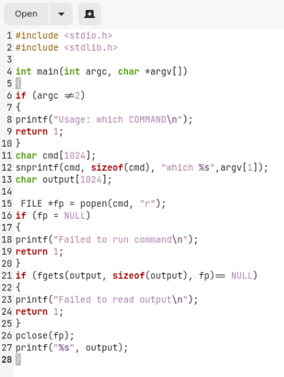

**Output:**

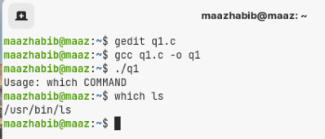

# Question no:2

**Implement the "Find" command.**

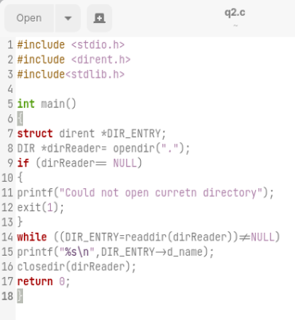

**Output**

